Software Design Fundamentals - Components
# Source: AI Source: Provided by: [Data Path: Persons Table -> ID Column: 1, Name_En Column: Motasem Essam] -> From: [ChatGPT] on [1/23/2026]
Components are the building blocks of a software system. Each component is a modular piece of code that has a specific responsibility and interacts with other components to form the complete system.
👉 Think of components like rooms in a building — each room has a purpose but works together as a whole.

🔑 Key Points
# Source: AI Source: Provided by: [Data Path: Persons Table -> ID Column: 1, Name_En Column: Motasem Essam] -> From: [ChatGPT] on [1/23/2026]
- Components are modular and reusable
- Each has a single responsibility
- Can be classes, modules, services, or libraries
- Communicate with each other through interfaces or APIs
- Help organize complex systems

🧱 Examples of Components
# Source: AI Source: Provided by: [Data Path: Persons Table -> ID Column: 1, Name_En Column: Motasem Essam] -> From: [ChatGPT] on [1/23/2026]
- Controller / Handler
  - Handles user input or requests
  - Example: UserController receives web requests
- Service / Business Logic
  - Contains the core processing and rules
  - Example: UserService processes user data
- Repository / Data Access
  - Handles storage and retrieval
  - Example: UserRepository interacts with the database
- Utility / Helper Modules
  - Provides reusable functions
  - Example: EmailService sends emails
- External API / Third-Party Services
  - Integrates external services
  - Example: Payment gateway or notification service

❌ Bad Example (No Component Separation)
# Source: AI Source: Provided by: [Data Path: Persons Table -> ID Column: 1, Name_En Column: Motasem Essam] -> From: [ChatGPT] on [1/23/2026]
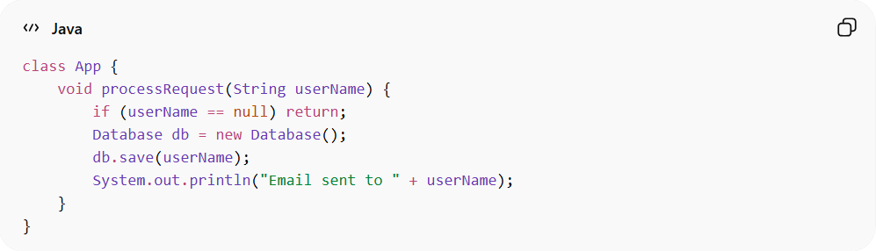
class App {
void processRequest(String userName) {
if (userName == null) return;
Database db = new Database();
db.save(userName);
System.out.println("Email sent to " + userName);
}
}
👉 Problems:
- Everything in one class
- Hard to test or maintain
- Logic, data access, and output are all mixed

✅ Good Example (Components Separated)
# Source: AI Source: Provided by: [Data Path: Persons Table -> ID Column: 1, Name_En Column: Motasem Essam] -> From: [ChatGPT] on [1/23/2026]
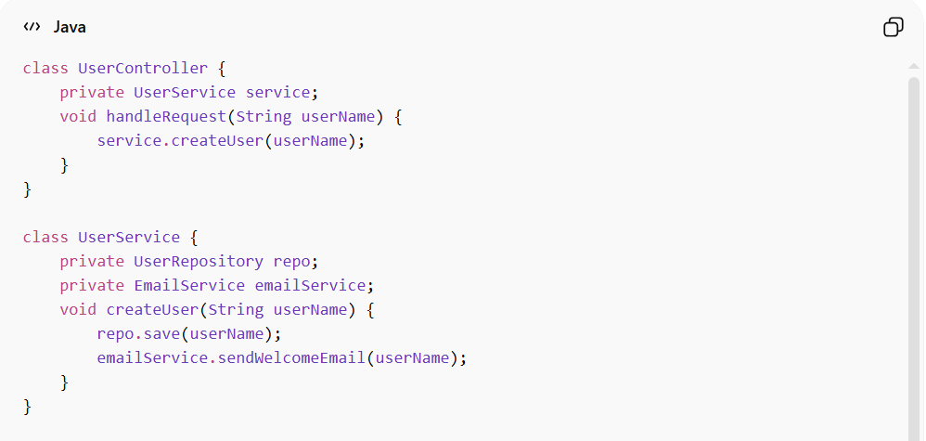
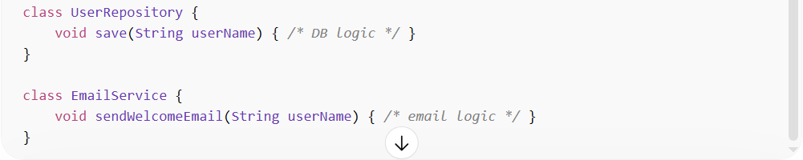
class UserController {
private UserService service;
void handleRequest(String userName) {
service.createUser(userName);
}
}

class UserService {
private UserRepository repo;
private EmailService emailService;
void createUser(String userName) {
repo.save(userName);
emailService.sendWelcomeEmail(userName);
}
}

class UserRepository {
void save(String userName) { /* DB logic */ }
}

class EmailService {
void sendWelcomeEmail(String userName) { /* email logic */ }
}
👉 Benefits:
- Clear responsibility for each component
- Easy to test components independently
- Easier to maintain and extend

💡 Summary
# Source: AI Source: Provided by: [Data Path: Persons Table -> ID Column: 1, Name_En Column: Motasem Essam] -> From: [ChatGPT] on [1/23/2026]
Components are the modular pieces of a system that encapsulate functionality and interact through well-defined interfaces.

